# Project Two: System Design Document

Ryan P. Gingery

Southern New Hampshire University

CS255: System Analysis and Design

Professor Aline Yurik

December 10, 2022

# CS 255 System Design Document Template

This template lays out all the different sections that you need to complete for Project Two. Each section has guidance to prompt your thinking. You will need to continually reference the interview transcript as you work to make sure that you are addressing your client’s needs. There is no required length for the final document. Instead the goal is to complete each section based on what your client’s needs are. Remove this note when you are finished, and replace all bracketed text with the relevant information.

## UML Diagrams

### UML Use Case Diagram

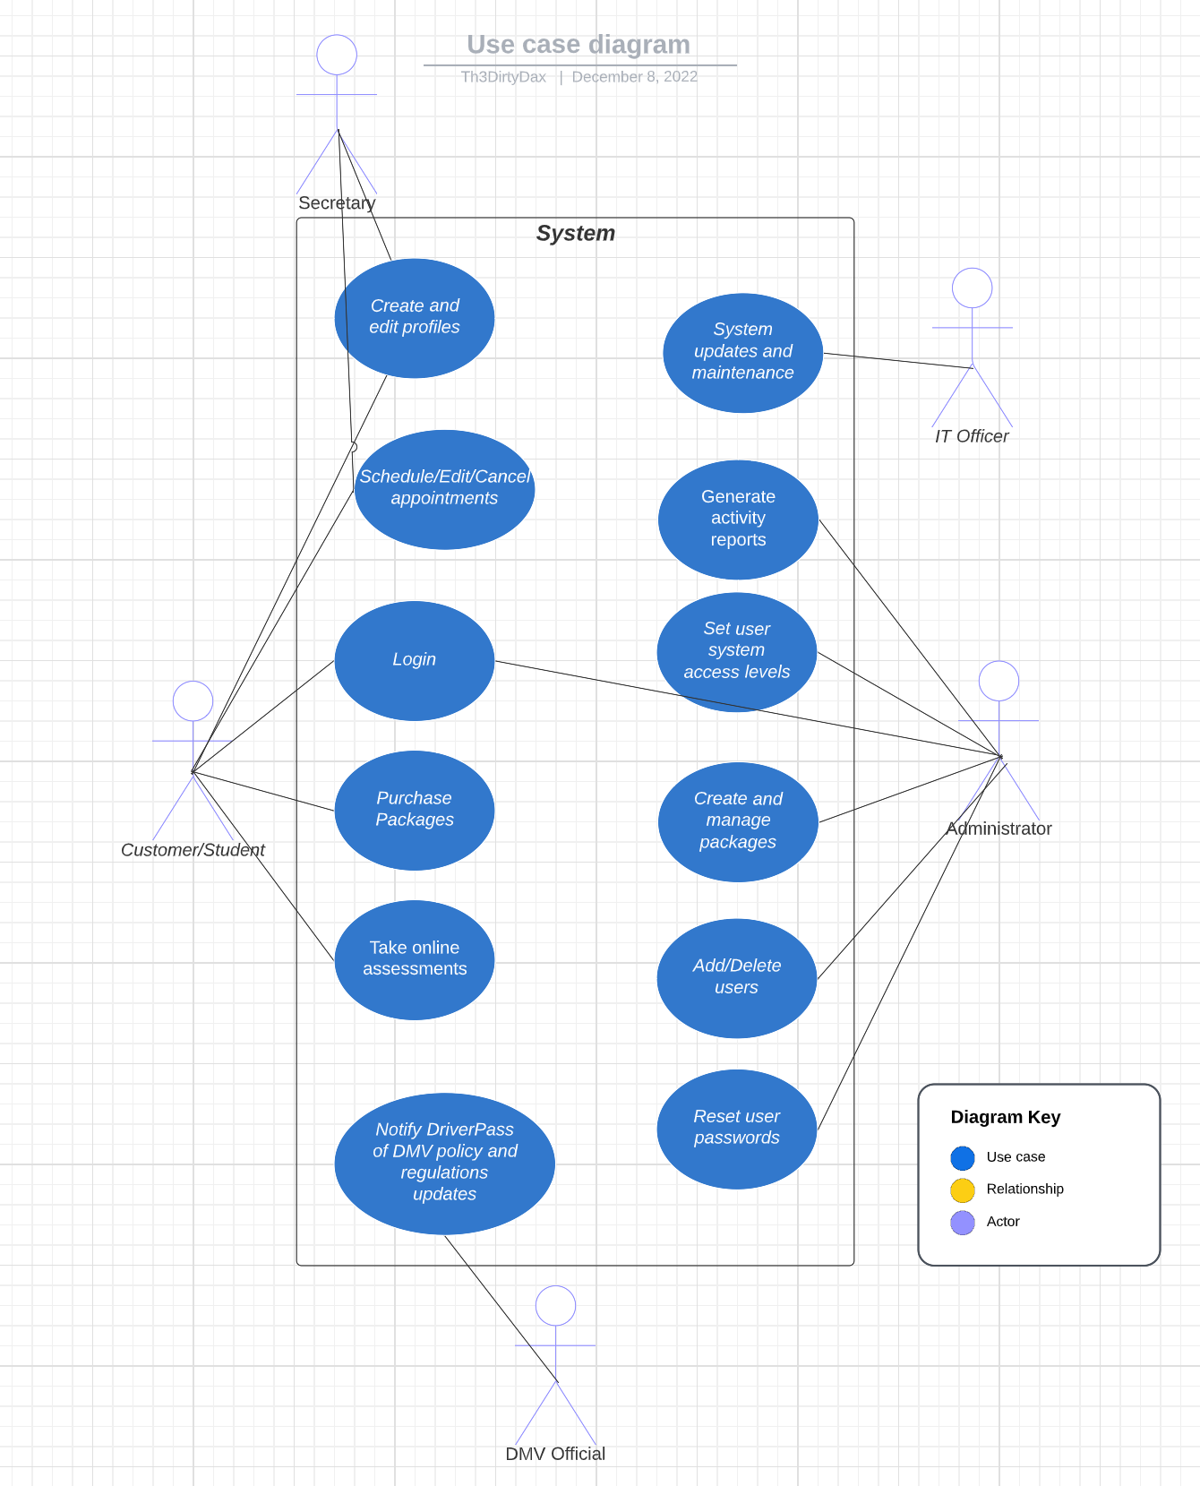

### UML Activity Diagrams

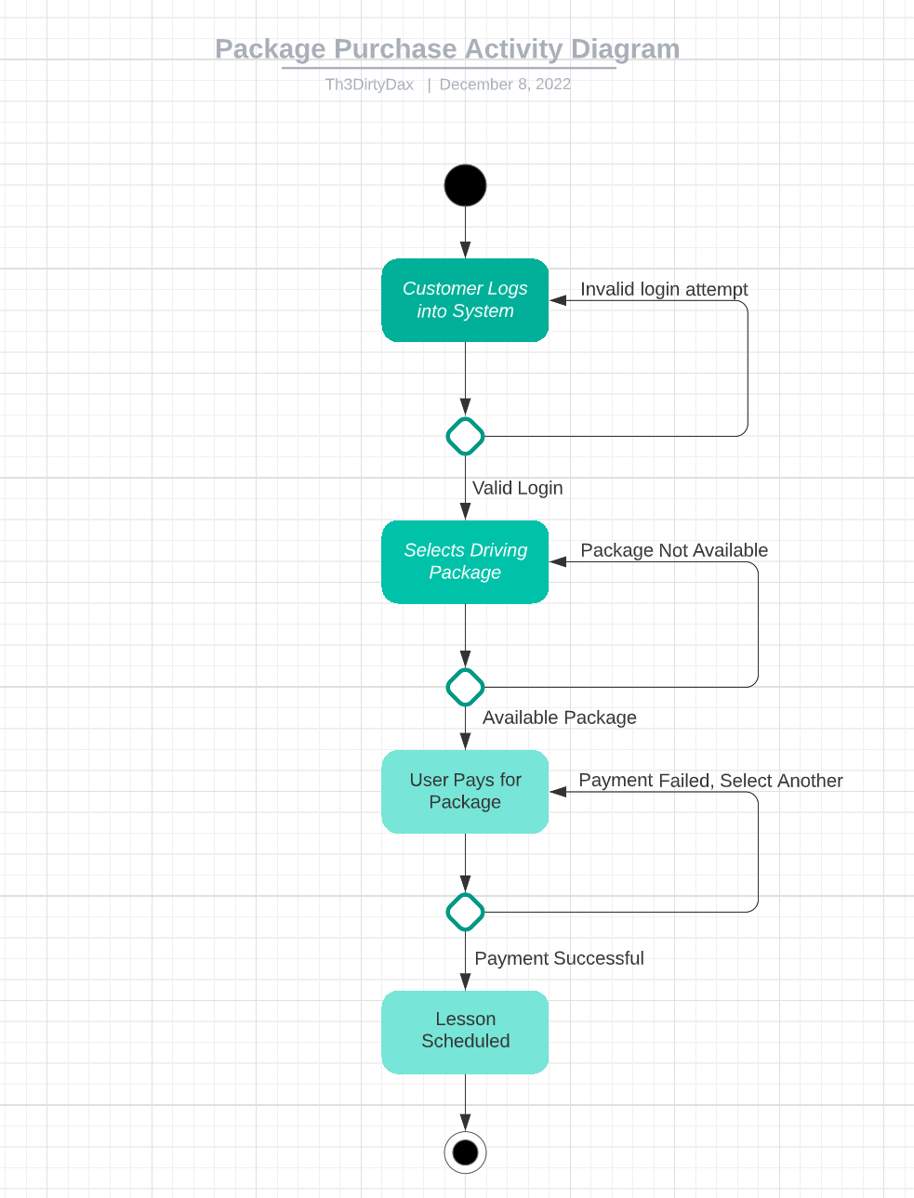

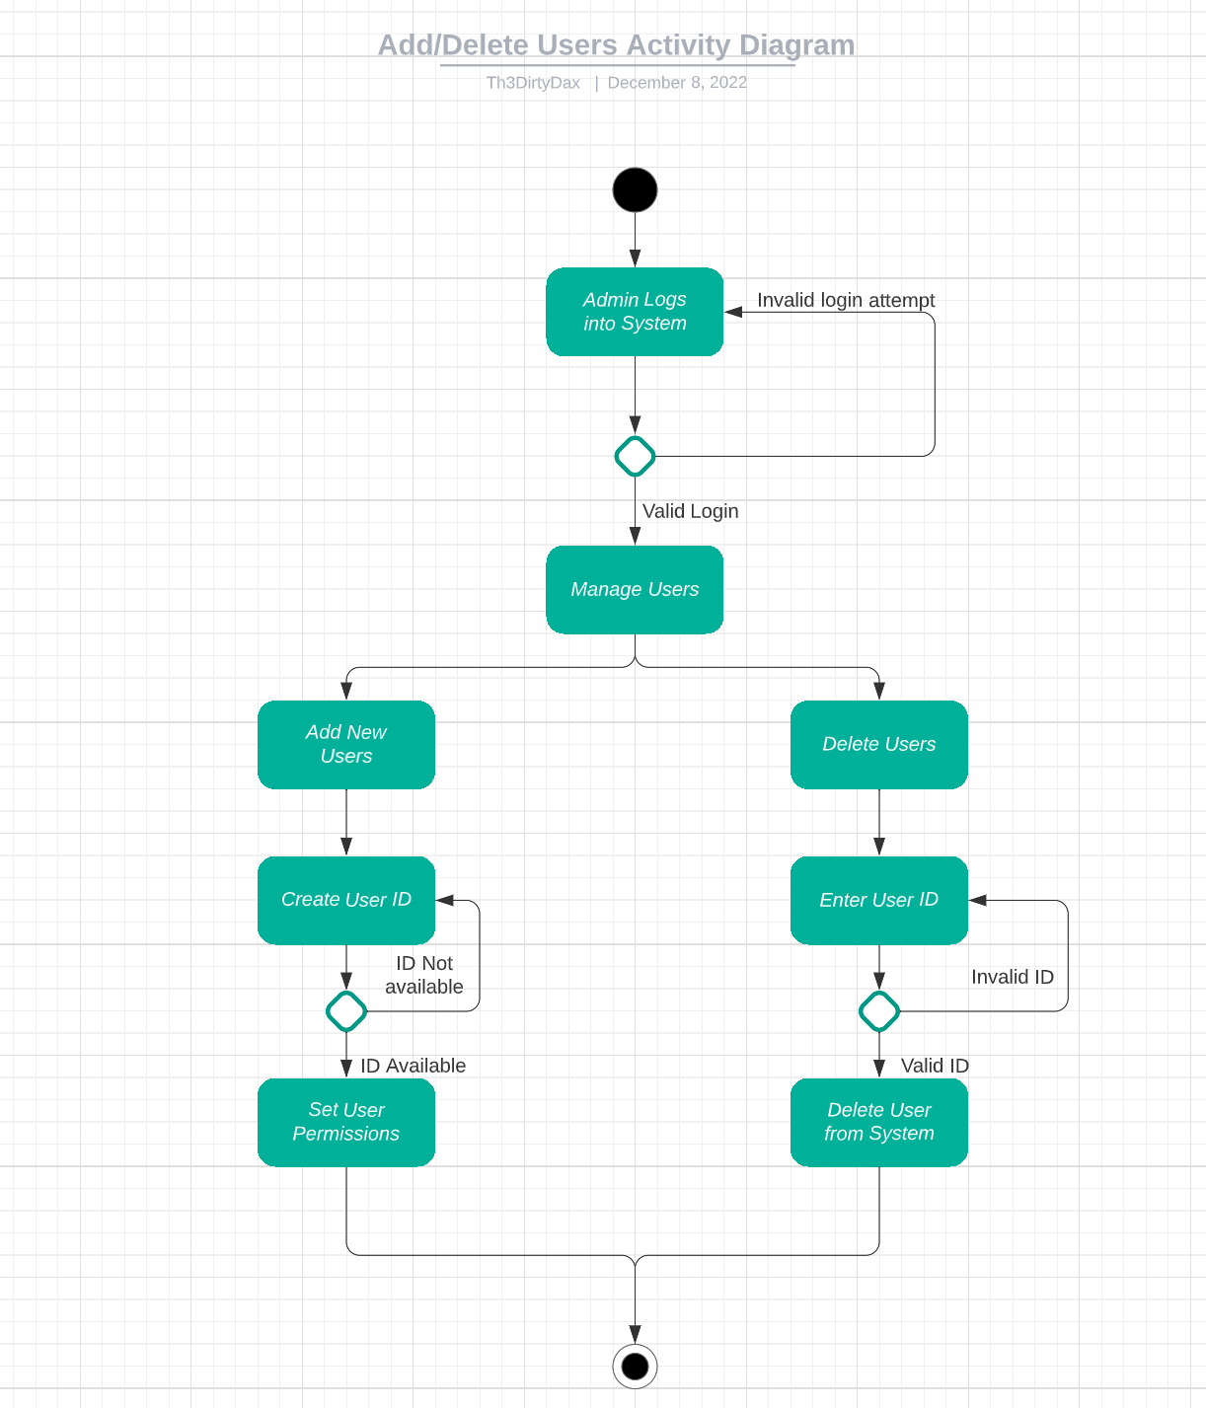

### UML Sequence Diagram

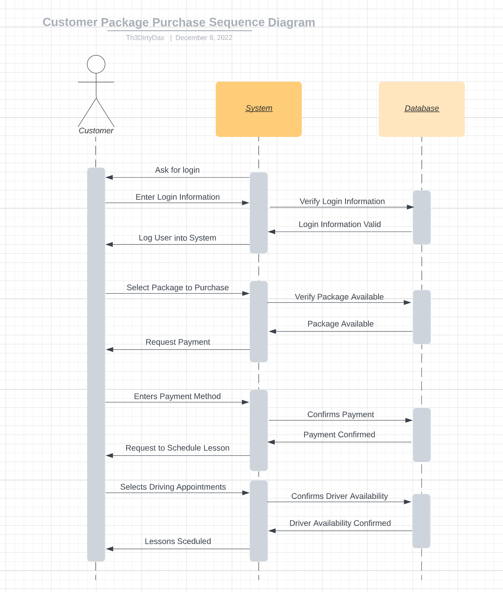

### UML Class Diagram

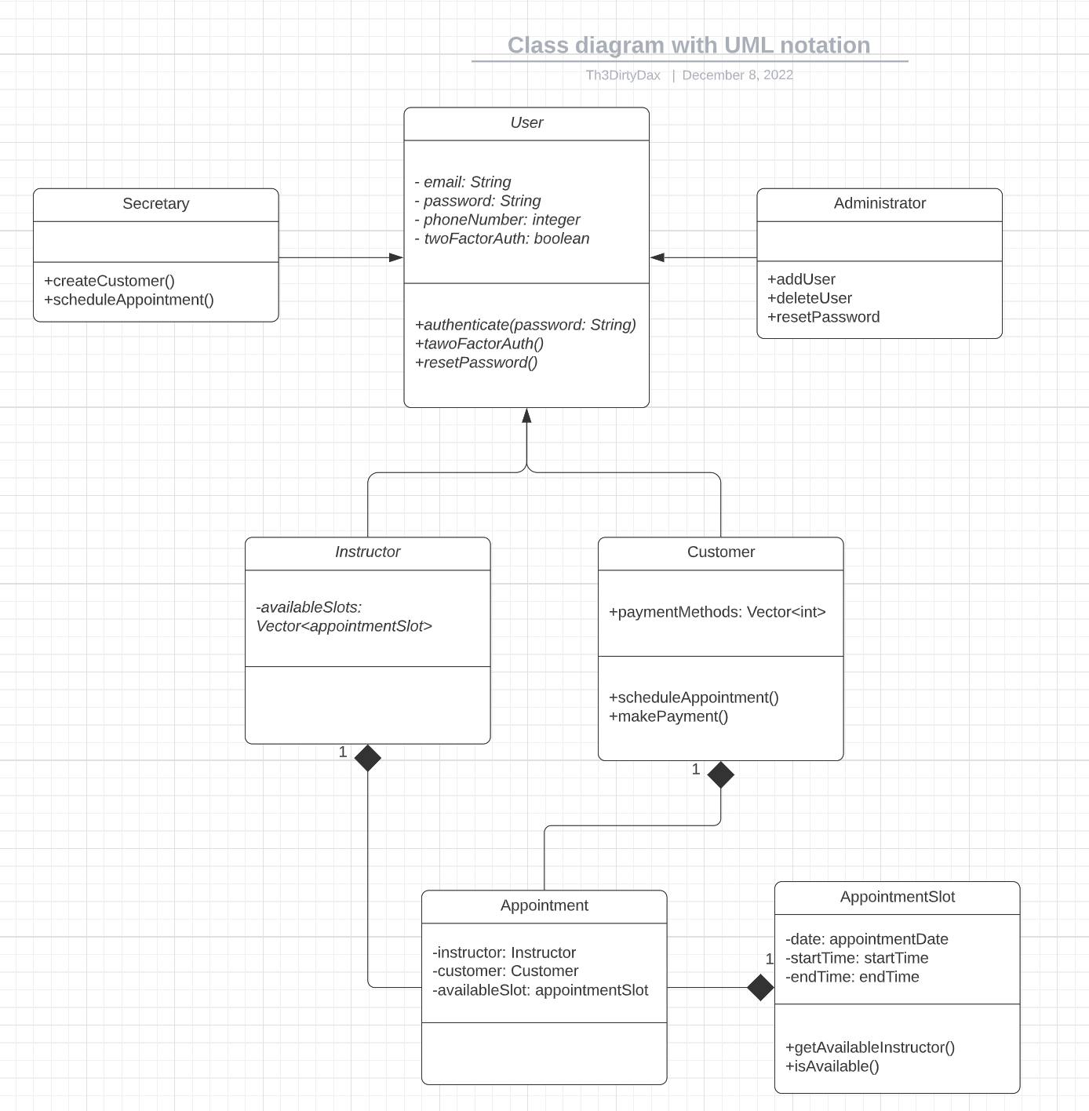

## Technical Requirements

There will be several technical requires for DriverPass based on the diagrams that have been create and supplied above. The system will need to be web-based with the ability to conform to mobile devices for users to interact with the system on the go. DriverPass will need either a cloud-based or physical data storing location to store information from the users, instructors, and other vital components that will allow for the success of the system. To ensure that all users information and data is protected there will need to be an encryption added to the transferring of data between locations. Users will need access to internet and some form of hardware that will allow them to access the tools and information before it can be downloaded for offline use.